PUBLIC NOTICE

The City of Prairie View, Texas, is requesting public comment in regard to the submission of application(s) to the Texas General Land Office (GLO) for Community Development Block Grant – Disaster Recovery (CDBG-DR) funds associated to Hurricane Harvey recovery. The application and proposed non-housing infrastructure projects will allow the City to utilize the following allocations prescribed by the Houston-Galveston Area Council of Governments (H-GAC) for long-term disaster recovery efforts:

- Local Infrastructure Program: $742,016.00

The City will request public comments for thirty (30) days from the date of this publication/posting. The public is encouraged to submit comments that will assist the City in defining and evaluting projects that will mitigate the devastating effects of natural disasters as well ensure the projects are in line with environmental regulations, affirmatively further fair housing activities, and, if applicable, minimizing displacement of persons by project activities.

Comments should address proposed infrastructure needs (i.e. drainage, streets, water and sewer, etc.) that can be directly tied to damage caused by Hurricane Harvey. Additionally, the City must document direct storm damage of proposed projects and expend funds that principally benefit low-to-moderate income areas of the city.

Upon the expiration of this comment period the City will review and address the public comments in the proposed application. Final project recommendations will be presented to the City Council prior to the submission of the application to the GLO on or before April 30, 2019.

Please email your views and comments to info@publicmgt.com, or mail your comments to:

Public Management, Inc.
c/o Prairie View Hurricane Harvey Disaster Recovery
P.O. Box 1827
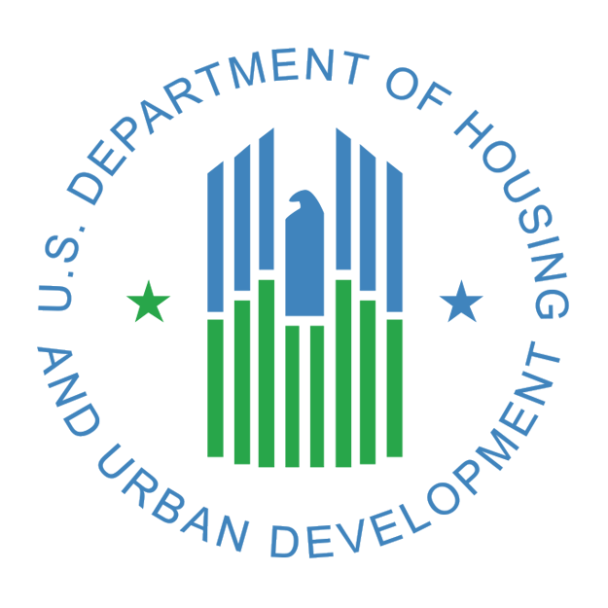
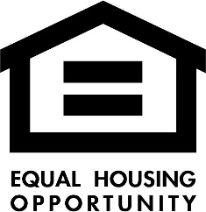
Cleveland, Texas 77328

